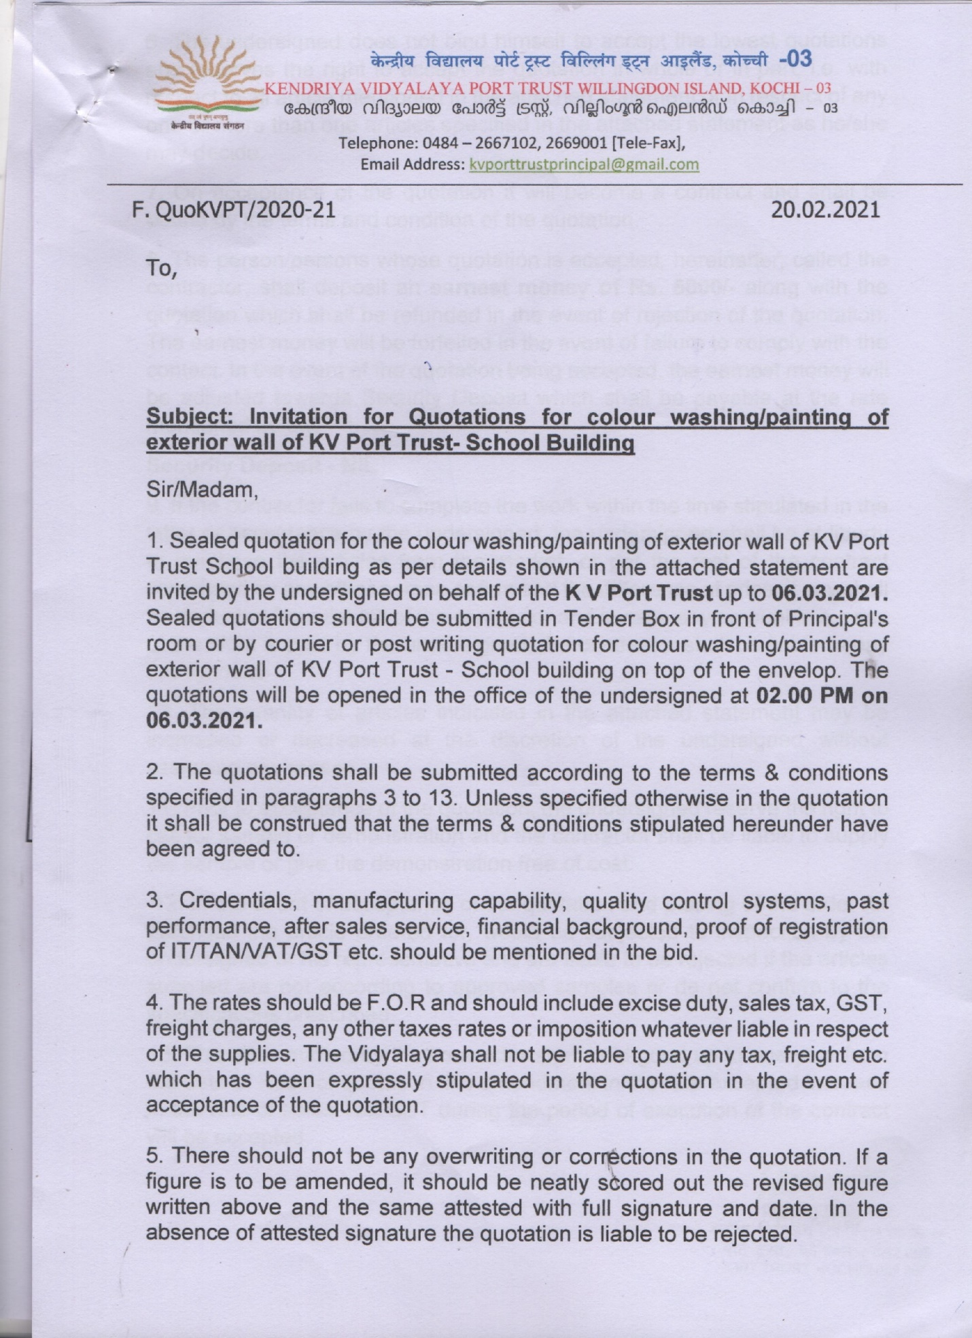

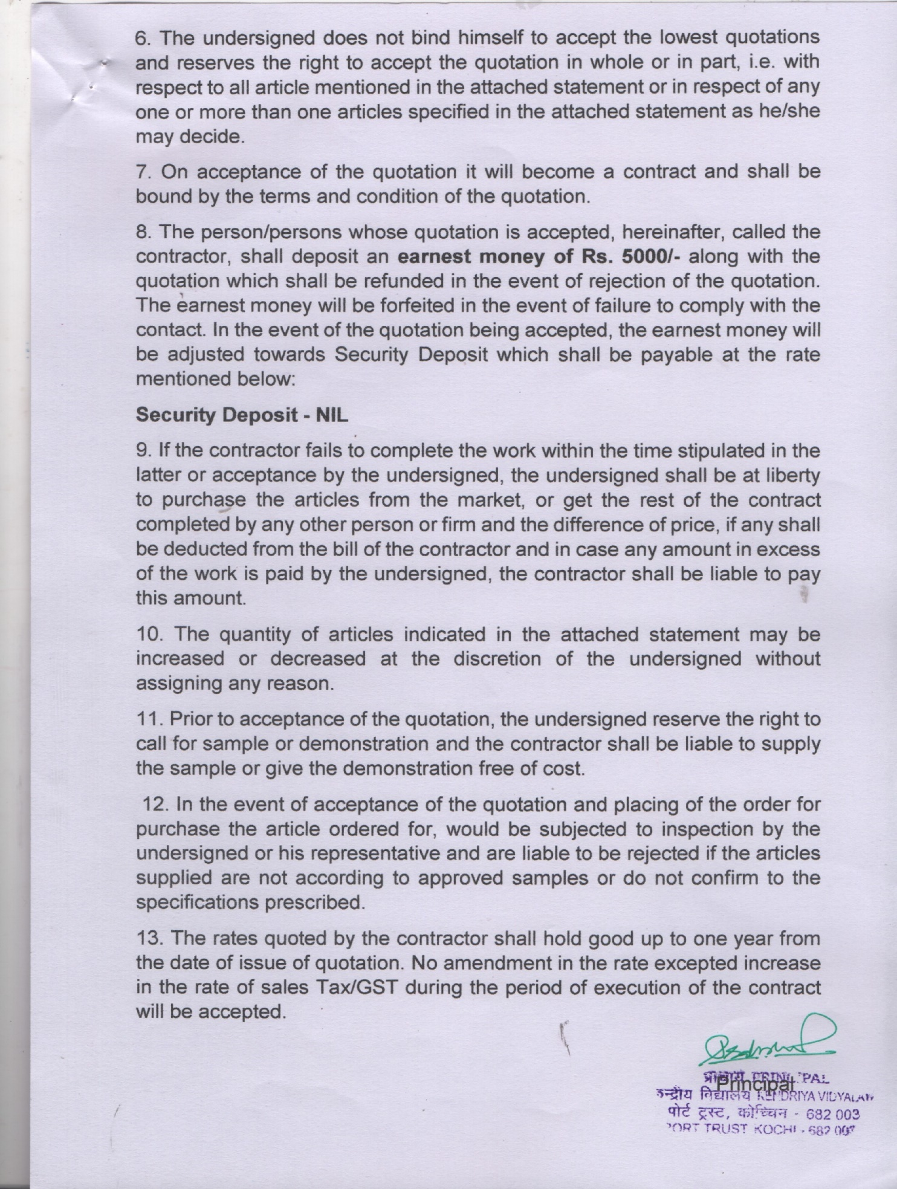

Annexure – I
KENDRIYA VIDYALAYA COCHIN PORT TRUST
TENDER FOR PAINTING OF EXTERNALWALLS
RATES SHALL BE INCLUSIVE OF LABOUR,MATERIAL, MACHINERY AND TAXES
SL No. | DSR Item | Description | Unit | Quantity | Rate | Amount
1 | 13.91 | Removing dry or oil bound distemper, water proofing cement paint and the like by scrapping, sand papering, pressure washing and preparing the surface smooth including necessary repairs to scratches etc. complete including cost of material, labour and machinery. | SQM | 4648.4
2 | 13.85.3 | Applying priming coats with primer of approved brand and manufacture, having low VOC (Volatile Organic Compound ) content. With water thinnable cement primer of BERGER or EQUIVALENT on wall surface having VOC content less than 50 grams/litre including cost of material, labour and machinery. | SQM | 4648.4
3 | 13.111.1 | Finishing walls with Acrylic Smooth exterior paint of BERGER or EQUIVALENT of required shade :  Old work (Two or more coat applied @ 1.67 ltr/ 10 sqm) on existing cement paint surface including cost of material, labour and machinery | SQM | 4648.4
4 | 13.62.1 | Painting with synthetic enamel paint of BERGER or EQUIVALENT of required colour to give an even shade for windows and ventilators:  Two or more coats on new work over an under coat of  suitable shade with ordinary paint of approved brand and manufacture, (Payment shall be given for flat area only, rates shall be quoted considering multiplication factors as per IS 1200 (Part 15-1987) | SQM | 736.72
5 | 13.99 | Painting roof tiles with terracoat colour with synthetic enamel paint of approved brand and manufacture of required colour to give an even shade One or more coats on old work | SQM | 259.08
 |  | Total Amount
 |  | Contingencies@ 3 %
 |  | Total
 |  | Centage @ 7%
 |  | Total
 |  | Add 18% GST
 |  | Grand Total
Date:- |  | Seal | Name, Signature and  full address of the firm

